***ELECTIONS COMMITTEE***

***2017 Instructions for Senator- at- Large Elections***

***to be held Monday, 24April 2017 and Tuesday, 25 April 2017***

1. **NJCU GothicNet Portal will be open *continuously* from Monday, April 24th at 9am until Tuesday, April 25th at 5pm.  If you have technical problems, please contact members of the Election Committee who are listed at the end of these Instructions.**
2. Log on to **GothicNet** portal using your logon ID and password.  The first content box on the top right will state **Vote 2017**.

***PLEASE NOTE THE SCREEN SHOTS BELOW ARE SAMPLES* – there are eight (8) vacancies for full-time faculty members and one (1) vacancy for a full time professional staff member (2017 SAL Elections)**

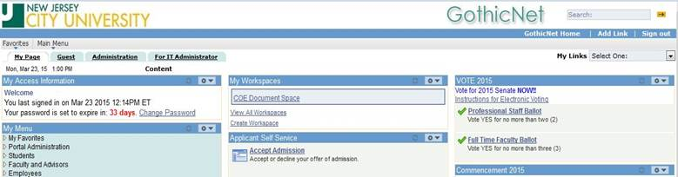

1. Click on either the **Professional Staff Ballot** link.  (SAMPLE FROM 2016)

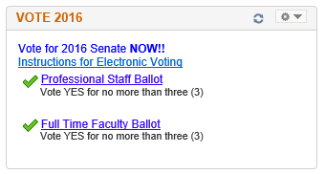

1. Once the ballot appears, vote **YES** for the allowed number of representatives according to your title and **NO** for all others

  (Full Time Professional staff no more than **one (1)**)

(Full Time Faculty no more than **eight (8)**)

**2016 Sample**

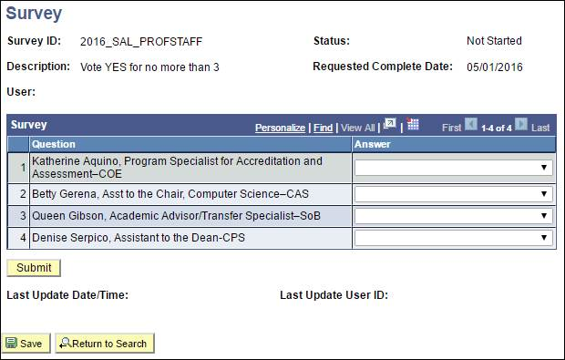

1. ***If you cast your vote for more than the allowed amount of nominees, your vote will be disqualified.***
2. Once you have made your selections, **press Submit** to record your vote.
3. If at any time during the voting process you need to navigate away from the screen before you complete your final vote, press save to save your vote.  Once you are ready to place your vote, log on to **GothicNet** again to resume your vote and press submit to record your vote.

**8.    If YOU HAVE ANY QUESTIONS OR NEED ASSISTANCE WITH THE VOTING PROCEDURES, PLEASE CONTACT THE FOLLOWING PEOPLE LISTED BELOW WHO WILL BE AVAILABLE TO ANSWER YOUR QUESTIONS ON BOTH VOTING DAYS (MONDAY & TUESDAY – APRIL 24th AND APRIL 25th) *FROM 9:00 AM – 5:00 PM.***

**9.** If you have begun your voting and anticipate a problem during the time the people listed below are not available, simply **press SAVE** (instruction #6) until you are able to resolve your problem. (Before the voting period ends at 5:00 PM on Tuesday, April 19th)

|  |  |
| --- | --- |
| **MONDAY  9:00 AM – 5:00 PM**    Chris Carnahan – Chairperson, Elections Committee Assistant - Educational Technology  [ccarnahan@njcu.edu](mailto:ccarnahan@njcu.edu)  201-200-2547  Mince John – Mathematics Dept. 201-200-3304  [mjohn@njcu.edu](mailto:mjohn@njcu.edu)  Amy Rady – Fitness, Exercise & Sports Dept. 201-200-3034 [arady@njcu.edu](mailto:arady@njcu.edu)  Mingshan Zhang – Accounting Dept 201- 200-2001 [mzhang@njcu.edu](mailto:mzhang@njcu.edu) | **TUESDAY 9:00 AM – 5:00 PM**     Chris Carnahan – Chairperson, Elections Committee Assistant - Educational Technology  [ccarnahan@njcu.edu](mailto:ccarnahan@njcu.edu)  201-200-2547  Mince John – Mathematics Dept. 201-200-3304  [mjohn@njcu.edu](mailto:mjohn@njcu.edu)  Amy Rady – Fitness, Exercise & Sports Dept. 201-200-3034 [arady@njcu.edu](mailto:arady@njcu.edu)  Mingshan Zhang – Accounting Dept 201- 200-2001 [mzhang@njcu.edu](mailto:mzhang@njcu.edu) |