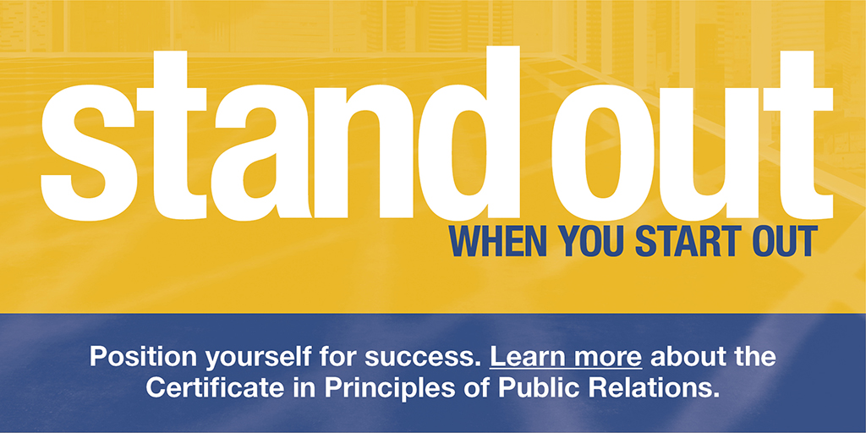

NJCU MARKETING MAJOR EARNS COVETED CERTIFICATE IN PRINCIPLES OF PUBLIC RELATIONS

[December 1, 2020]: Valerie Gonzalez, a 2020 graduate of the NJCU School of Business has passed the Certificate in Principles of Public Relations Examination through the Universal Accreditation Board (UAB), which includes nine participating public relations professionals organizations. The Certificate in Principles of Public Relations is an entry-level certificate designed to demonstrate a fundamental level of knowledge for graduates entering the public relations profession that helps those who earn it #StandOutInPR.

Gonzalez is the seventh student to graduate with a Marketing degree to pass the examination. She joins Nicole Ortiz, Monika Palkowski, Nicole Manzione, Thi Swander, Natasha Veras, and Shayne Cannata in this accomplishment.

"The Certificate in Principles of Public Relations gives these emerging professionals a competitive edge in the job market," said Dr. Kathleen Rennie, chair of the NJCU Marketing Department. "It distinguishes Valerie and her fellow NJCU graduates as rising professionals among their peers who understand the core elements of strategic communication and real-world application of important concepts.”

“Earning the Certificate in Principles of Public Relations helped strengthen my knowledge of strategic communication models, theories, ethics, and laws,” said Valerie Gonzalez. “The certificate provides me with a solid foundation of applicable information that will assist me in advancing my career as a young professional.”

The UAB administers several programs to promote lifelong learning in the public relations profession and related fields, including Accreditation in Public Relations (APR), a designation earned by professionals that demonstrates competency in the knowledge, skills, and abilities required to practice public relations effectively and strategically. The Certificate helps set the stage for students to think about the APR and other opportunities to grow as a professional through the course of their career.

To qualify for the Certificate examination, students must (a) be within six months of graduation (before or after) from an accredited college or university whose undergraduate or master’s degree is in public relations or a related area of study; AND (b) be members or affiliate members of the Public Relations Student Society of America or student member of another UAB Participating Organization, such as the Florida Public Relations Association or the Southern Public Relations Federation; AND (c) complete a campus-based Certificate preparatory course or the Certificate in Principles of Public Relations Online Study Course.

Examination topics include strategic planning (research, planning, implementation and evaluation process), media relations, communication models and theories, information technology, and ethics and laws. Each student takes the examination on their own schedule at a testing center.

More information about the Certificate and the UAB is available at http://www.prcertificate.org
###

