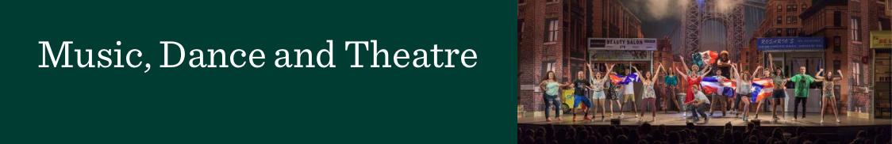

RECITAL APPROVAL FORM

____________________________________ ____________________________________
Name Phone

_________________________________________________
E-Mail Address

_________________________________________________
Requested Location for Recital

____________________ ___________________ ________________________________
Requested Date Requested Time Accompanist’s Name

Type of Recital (Circle One Only)

BM Junior BM or BA Senior Recital

MM Lecture/Thesis MM Performance Recital

Specific Equipment Needs (projector, sound system, etc.. ):

_____________________________________________________

NOTE! BEFORE obtaining all signatures please meet with your accompanist and private instructor to come up with possible dates for your recital. After coming to a consensus, please contact Erica Seitzman (ESeitzman@njcu.edu) to see if any of those dates are available in the calendar. After that please obtain all signatures required before in the order give. After all signatures have been obtained please return your completed form to Erica Seitzman in the main MDT office to official book your recital.

Required Signatures:

- Applied Instructor: _____________________________________ Date: _______

- Area Coordinator: ______________________________________ Date: _______

- Accompanist: _________________________________________ Date: _______

- Production Services Dir: _________________________________ Date: _______

- MDT Program Assistant (E. Seitzman): ______________________ Date: _______

